**Practical Activity 4**

Write a shell script that validates a password strength. The password should be alphanumeric, contain uppercase and lowercase characters and not less than 8 characters. If the password doesn’t comply, it should return a result of weak password otherwise it should return that the password is a strong password.

First create the script file then edit the file using **nano.** 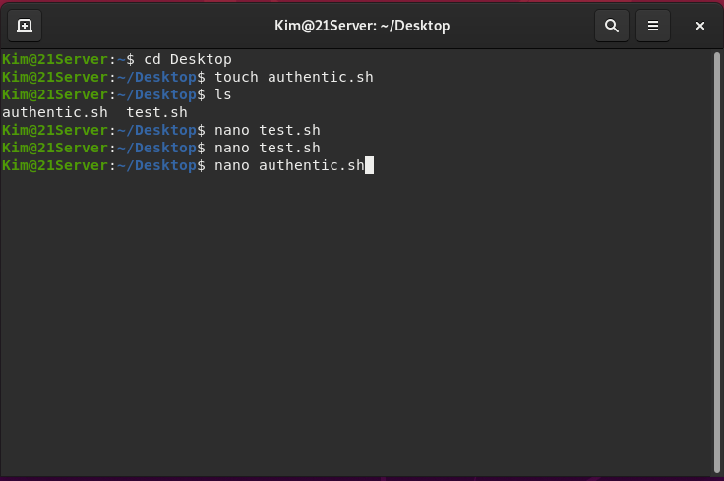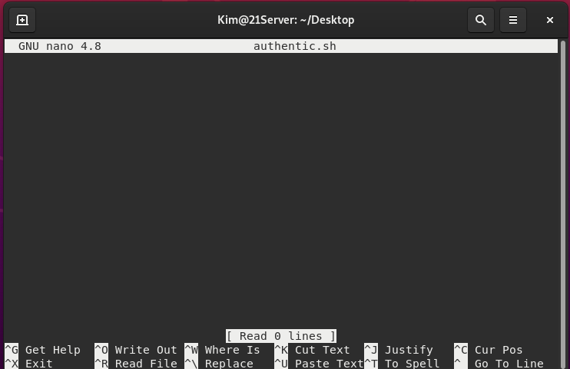

Edit the **authentic.sh** file using with the bash script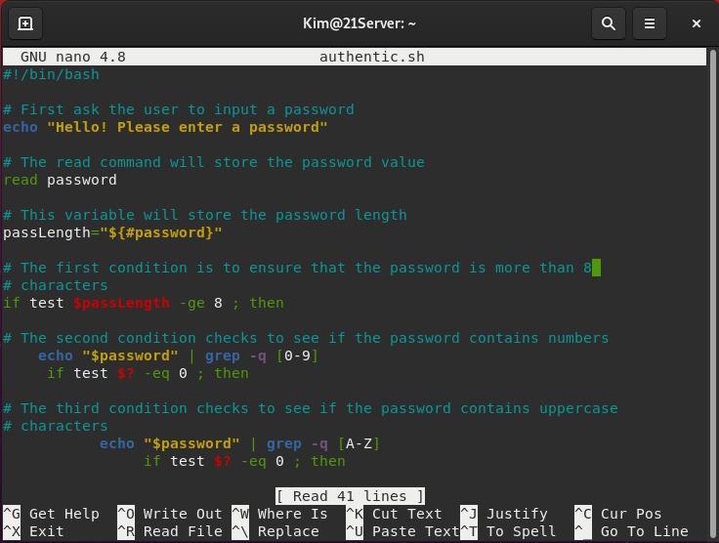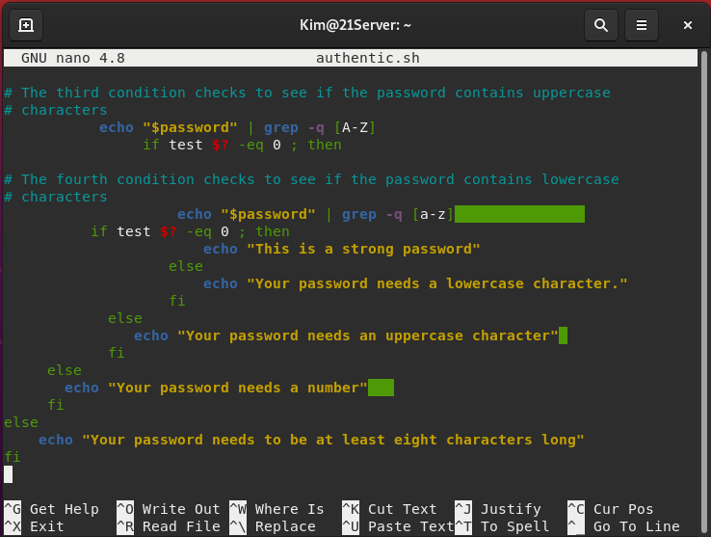

Save the script and run it to test.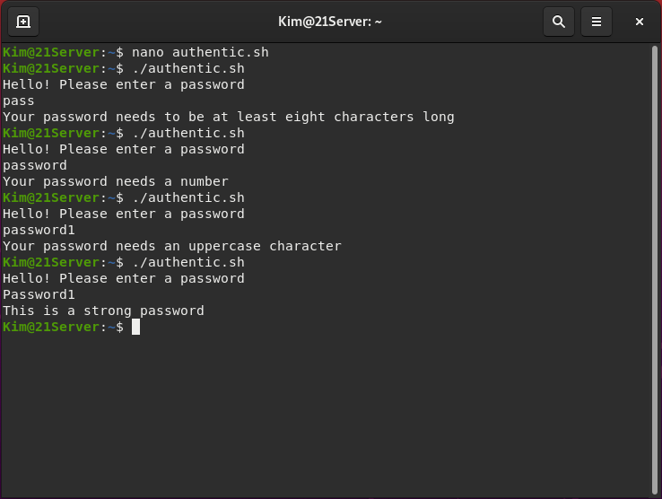

The authentication script works!